Lab 09 Nested Types, Enums and Records
Solutions follow the lab manual’s concepts and use simple comments. Output shown is representative; interactive programs require the stated input.

Exercise 1
Question: Enum Level LOW/MEDIUM/HIGH with switch advice.
public class Exercise1LevelEnum {
enum Level {
LOW, MEDIUM, HIGH
}

static void advise(Level level) {
switch (level) {
case LOW -> System.out.println("Keep monitoring");
case MEDIUM -> System.out.println("Take care");
case HIGH -> System.out.println("Act immediately");
}
}

public static void main(String[] args) {
// values() visits each declared level in order.
for (Level level : Level.values()) {
advise(level);
}
}
}

Expected output (sample):
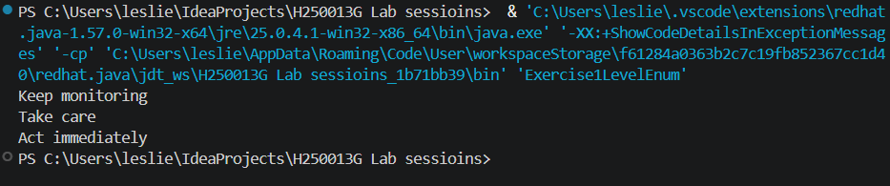Explanation: An enum defines a fixed set of named values. The switch gives advice for each value.

Exercise 2
Question: Create Student record; print, compare equal records and read a component.
Java source code:
public class Exercise2StudentRecord {
record Student(String name,int age) { }
public static void main(String[] args) { Student a=new Student("Leslie Sarai",21); Student b=new Student("Leslie Sarai",21); System.out.println(a); System.out.println("Equal: "+a.equals(b)); System.out.println("Name: "+a.name()); }
}
Expected output (sample):
Student[name=Leslie Sarai, age=21]
Equal: true
Name: Leslie Sarai
Explanation: Records automatically provide a constructor, component accessors, equals(), hashCode() and toString().

Exercise 3
Question: Book equals/hashCode by ISBN; prove HashSet rejects duplicate ISBN.
Java source code:
import java.util.*;
public class Exercise3BookSet {
static class Book { String isbn,title; Book(String i,String t){isbn=i;title=t;} public boolean equals(Object o){return o instanceof Book b && isbn.equals(b.isbn);} public int hashCode(){return isbn.hashCode();} }
public static void main(String[] args) { Set<Book> books=new HashSet<>(); books.add(new Book("123","Java Basics")); books.add(new Book("123","Java Basics second copy")); System.out.println("Unique books: "+books.size()); }
}
Expected output (sample):
Unique books: 1
Explanation: HashSet uses equals() and hashCode(). Books with the same ISBN are treated as duplicates.

Exercise 4
Question: LinkedList with private static Node and inner Iterator for for-each.
Java source code:
import java.util.*;
public class Exercise4LinkedListIterator implements Iterable<String> {
private static class Node { String value; Node next; Node(String v){value=v;} }
private Node head,tail;
void add(String value){Node n=new Node(value);if(head==null)head=n;else tail.next=n;tail=n;}
public Iterator<String> iterator(){return new Iterator<>(){Node current=head;public boolean hasNext(){return current!=null;}public String next(){if(!hasNext())throw new NoSuchElementException();String v=current.value;current=current.next;return v;}};}
public static void main(String[] args){Exercise4LinkedListIterator list=new Exercise4LinkedListIterator();list.add("Java");list.add("OOP");for(String item:list)System.out.println(item);}
}
Expected output (sample):
Java
OOP
Explanation: Node links each item to the next. The iterator supplies hasNext() and next(), enabling the for-each loop.

Exercise 5
Question: Coin enum with values and fewest coins for amount.
Java source code:
public class Exercise5CoinChange {
enum Coin { QUARTER(25), DIME(10), NICKEL(5), PENNY(1); final int value; Coin(int value){this.value=value;} }
public static void main(String[] args) { int amount=41; for(Coin c:Coin.values()){int count=amount/c.value;if(count>0){System.out.println(c+": "+count);amount%=c.value;}} }
}
Expected output (sample):
QUARTER: 1
DIME: 1
NICKEL: 1
PENNY: 1
Explanation: Coins are considered from largest to smallest. Integer division gives the count, and remainder gives the amount left.

How to run
Open the Java_Files folder in IntelliJ IDEA. Open the exercise file and run its main() method. Alternatively, open a terminal in Java_Files and run: javac ExerciseFile.java, then java ExerciseClassName. JDK 17 or later is recommended.

